**GAME DESIGN DOCUMENT (TEAM AWESOME POSSUM)**

Game Name: Speed Bump

Class: GAM150S15-B

Semester: Spring 2015

Team Name: Awesome Possum

Team Roster:

Marcus Chua (Producer)

Jovi Tan (Technical Lead)

Zhiming Chen (Product Manager)

Lucas Ng Jun Wei (Design Lead)

Coding Responsibilities:

Marcus – Framework, Engine

Jovi –Engine, Physics

Zhiming – Demo, Game Logic

Lucas – Game Logic

Table of Contents

**HIGH CONCEPT3**

**SUMMARY3**

**GAME FLOW4**

**GAME MECHANICS5**

**GAME CHARACTERS6**

**GAME RESOURCES6**

**GAME ENVIRONMENT7**

**GAME CONTROLS8**

**VISUAL DESIGN8**

**AUDIO DESIGN8**

**BEHAVIOUR DESIGN9**

**PHYSICS DESIGN9**

**MULTIPLAYER DESIGN9**

**HIGH CONCEPT**

A top-down, 2D, fast-paced, action, multiplayer, two button party game that takes inspiration from Mario Kart and Smash Bros, with a unique movement system.

**SUMMARY**

Speed Bump is a frantic, fast paced action multiplayer game for up to four players in the vein of Mario Kart mixed with Smash Bros. Like those games, the objective of the game is to knock into opponents using both accelerated boosts and power-ups in order to knock them out of the arena and be the last person or team standing. Also featured is a single-player mode, for new players eager to learn the ropes without having to dive right into the competitive scene.

Introducing a unique movement system where direction is center stage, this system will only require the use of two buttons per player, one to control the direction that the player is turning and the other to perform acceleration or power-ups. With very few controls, it makes it easy to just pick up and play by most everyone.

Boasting stylized cartoony graphics and audio that is bound to make competition light-hearted, it will be a blast to play for both young kids and their parents together and share in the fun.

**GAME FLOW**

When the players begin the game in multiplayer, they will start on opposite sides of the map. From there, they will start to maneuver into optimal positions in order to draw first blood on enemies. As soon as the first hit is registered, power-ups will start to spawn. This will create natural battlegrounds throughout the map that players will fight over, keeping the action in set locations.

After that, players will use both acceleration and power-ups to aid them in damaging their opponents, the result of which will start to lower the barriers around the arena. After a certain threshold, players will then be able to knock opponents out of the arena boundaries, eliminating them from the game. At this point, players will start to become either more aggressive or more defensive in their tactics in varying strategies on being the last one standing, due to damage determining how easy a player can be knocked out. This cycle continues until one player or one team is left standing. A standard multiplayer session should take roughly around 10 to 15 minutes.

When playing multiplayer, the experience will be one that demands constant attention and on-the-fly thinking from the player to deal with any unexpected situation that may arise.

In terms of single-player, the idea behind it is as an extended tutorial, allowing new players to get used to the movement system, navigation, the use of the power-ups, the acceleration mechanic and etcetera. Starting from relatively easy levels, the level of difficulty will start to ramp up with each level in accordance with the player’s growing skill level. That rise in difficulty will also provide a tangible challenge for the player to overcome, providing motivation for them to accomplish the given goals.

**GAME MECHANICS**

The first mechanic is the movement system, which involves turning. When players begin, their car will start to turn right constantly in a continuous circle. By pressing or holding down a button, players will change the turn direction from right to left. The second mechanic is the acceleration/power-up mechanic. When players wish to accelerate, they will have to hold down another button, bringing up a pointer in front of the player. This will indicate the direction they will accelerate in, allowing them to time it right in order to collide with other players. However, this skill can only be used should the player be devoid of a power-up. If they do have a power-up, the button will instead activate the power-up.

In multiplayer, the player loses when his car is knocked out of the arena boundaries. The player must be the last man standing or part of the last team standing in order to win. Damage is taken by colliding with walls, obstacles and other players, which will make it easier for them to be knocked out. In single-player, the goal of the game is to reach the end of the level. The player loses in single-player when he collides with a wall or an obstacle.

***A stretch goal for this project would be the implementation of an upgrade system in multiplayer, where players will be able to swap parts of their cars. The upgrades are not progressive. Instead, they will be side-upgrades, items that have different yet still useful bonuses.***

**GAME CHARACTERS**

There are four racers, represented by their color to serve. They will look like different colored cars, with one or two differing features to make them stand out for the players. Their stats and abilities will remain the same, to keep a sense of fairness when competing in multiplayer. Below is a rough demonstration of how the cars will differ from one another.

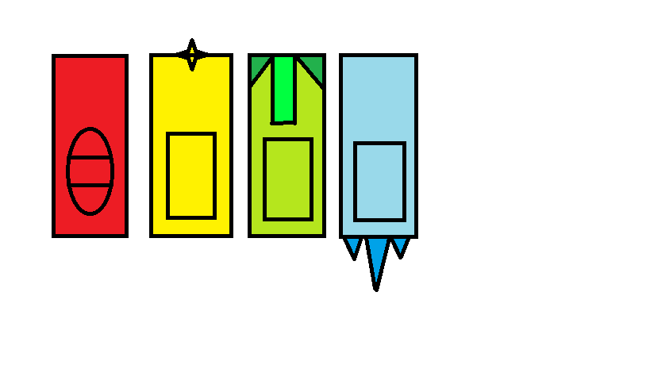

Their purpose is to allow players to easily identify which car they are controlling, thus cutting down on possible confusion that may occur during the match.

**GAME RESOURCES**

Powers-ups will be one of the main resources in the game, granting abilities to players in order for them to accomplish the goal of the game. A total of four or five power-ups will be in the game, subject to change.

***Other resources includes varying parts for subsets of the car, allowing players to customize their car to their play-style.***

**GAME ENVIRONMENT**

In general, players will encounter walls that will limit where players are able to traverse. When hitting the walls or the varying obstacles, the player will bounce off them and taking an amount of damage dependant on the object in question, thereby resetting them in a position to move again and penalizing them for running into it. Power-ups will also spawn in at pre-set locations set throughout the maps, denoted by a distinct square mat.

The maps will be split into two, arenas for multiplayer and tracks for single-player. Single-player maps will be designed to introduce and educate players on the mechanics at play and the controls. For example, the first three levels will go something like this.

First level - A simple square box where players are free to experiment with the controls without any constraints or restrictions.

Second level - Long and wide straight road to test players on how to use the movement system to traverse a straight line adequately.

Third level - Combines having to travel in straight lines and turning into one map, which will look like a rectangle with curved sides, similar to standard race tracks.

***The single-player will consist of 10 levels, each made to teach a specific aspect of the game or to combine mechanics and teach players about the interlocking systems.***

Multiplayer arenas will have their own quirks and strategies per map. One example is again the square box. This type of arena is the most basic, where obstacles are at a bare minimum and power-up locations are very straightforward. This serves as both a perfect proving ground for new players and an easy place to hone skills due to a lower amount of luck involved.

***A total of three arenas are planned for multiplayer, in order to allow for polish within the maps.***

**GAME CONTROLS**

The controls of the game are simplified in order to allow the audience to familiarize with the controls in a short amount of time. There will be two buttons for each player, one that changes the direction the player starts to turn and another button to either increase acceleration or use items, depending on the situation. For the acceleration, there will be a pointer in front of the player controlled cars to inform them of what direction the acceleration will take them. The power-up collected by players will also be represented on-screen at one of the four corners, allowing players to determine what power-up they have and whether they can use the acceleration boost or not.

**VISUAL DESIGN**

In terms of visual, the game will have less of a realistic look and lean more towards a more stylized, cartoony look to keep the game light-hearted for the younger audience. The perspective of the game will be top-down while the game’s visuals done in 2D. For special effects, acceleration will be shown by a particle effect behind the player, power-ups will emit a burst of particles when collected and collision between players with other players and the environment will emit sparks. The camera will be zoomed out, laying out the entire map onscreen for all players to see.

**AUDIO DESIGN**

The game will incorporate several realistic elements such as the car sounds and the collision between players and the environment. However, several more cartoonish sounds will be implemented when collecting power-ups and in using said power-ups. The idea is to provide a contrast in order to keep the game light-hearted while giving it an action flair that might engender it more to the audience. There will be accompanying background music to preside over the matches as well as in the main menu to provide ambience to it. For these, a slowly rising tempo climaxing with a bang is the projected tune for it.

***In addition, one of the stretch goals would be the introduction of an announcer to preside over the game, occasionally commenting on player and game status from time to time.***

**BEHAVIOUR DESIGN**

There will be no AI bots in the game, either for single-player or multi-player. The inclusion of bots would detract from the social element of multi-player and potentially interfere with player progression in single-player.

**PHYSICS DESIGN**

The game will use acceleration via an on-screen pointer in the direction the player is facing, providing a burst of speed in that direction. Aside from that, there will also be rotation of the cars, the direction of which is determinant on player input. Finally, there will be a simple collision between players versus players, players versus environment and players versus power-ups in order to get to the win/lose condition of knocking opponents off the map.

**MULTIPLAYER DESIGN**

The game will support up to four players, with three players using keyboard keys to control the game while the fourth uses the mouse buttons. As such, multiplayer will occur on one single machine. There will be competitive modes available, such as the standard free-for-all death-match and team death-match. The victory conditions for multiplayer will differ from single-player in that the goal is to be the last person or team standing, whereas the single-player has a more traditional ‘Point A to Point B’ objective. However, the victory conditions will not change depending on the number of players in the game. If there are less than four players, there will be no AI bots to replace them.